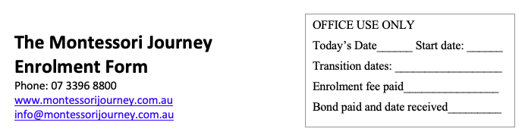
The Montessori Journey
Waiting List Form

Phone: 07 3396 8800
www.montessorijourney.com.au
info@montessorijourney.com.au

Child’s first name |  |  | Second name |  |  |  |  | Surname

Address
Telephone |  |  |  |  | Nationality
Sex |  | DOB |  |  |  |  | Country of Birth

Primary language spoken at home

Does your child speak English? Yes No

Guardian information
Title |  | Name |  | Surname
Relationship to the child |  |  |  | Mobile
Address |  |  |  | Email

Application for a position
Days you wish your child to attend |  |  | Mon. Tus. Wed. Thur. Fri.
Hours of care |  | 1st attendance date |  | Age of 1st attendance
Has your child been in childcare before? |  |  |  | Yes No

Medical History
Does your child have any hearing or visual problems? | Yes No
If yes, please provide details:

Does your child have any physical or emotional problems, language or speech difficulties, developmental delays, special needs or challenging behaviours that we should be aware of? |  | Yes No
If yes, please provide details:

Thank You
Please return this form, together with the $10 non-refundable application fee, to the Centre via mail or in person. Your child’s name will be placed on our Waiting List and you will be contacted as soon as there is a vacancy available. Should you wish to discuss any aspect of this application, please call the Director directly on (07)3396 8800.

